## **WEB SCRAPING ASSINGMENT BEAUTIFUL SOUP -1(2)**

## **NAME – SUBHAM**

## **BATCH – DS2401**

**Q1-Please visit**[**https://www.cnbc.com/world/?region=world**](https://www.cnbc.com/world/?region=world)**and scrap-**

**a) headings**

**b) date**

**c) News link**

Ans)

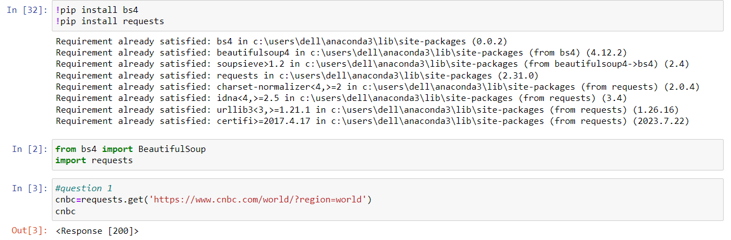

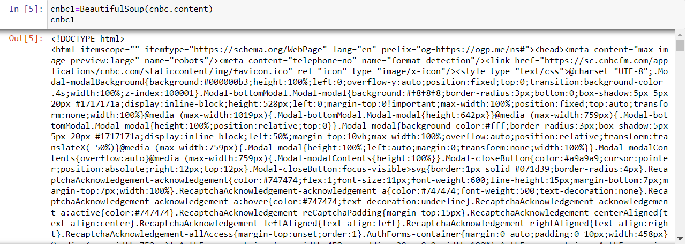

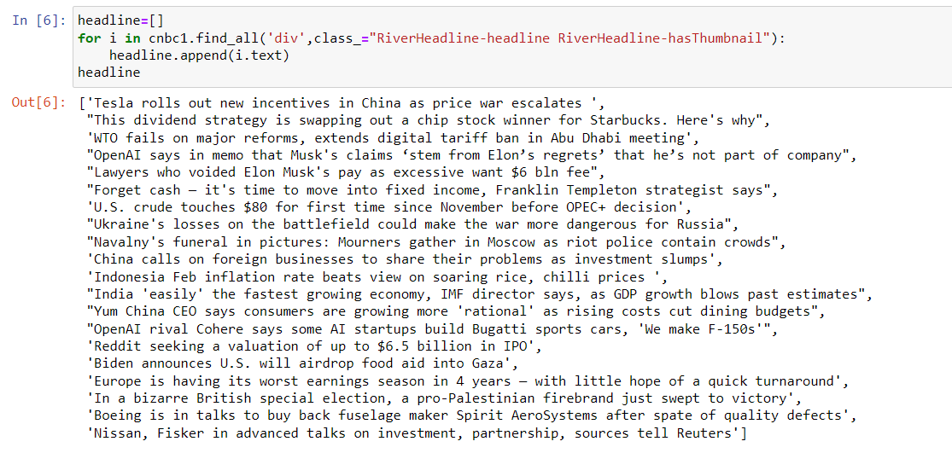

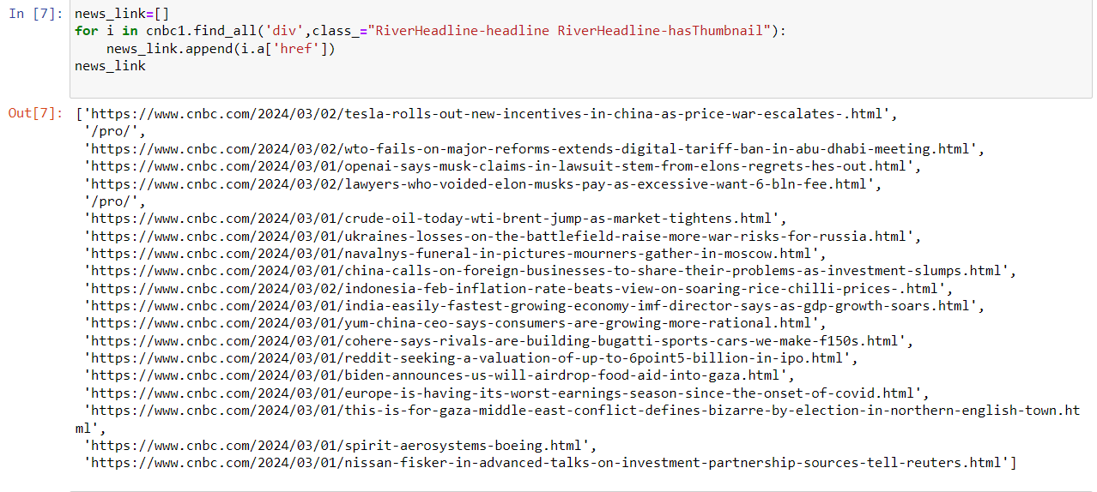

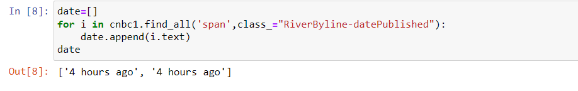

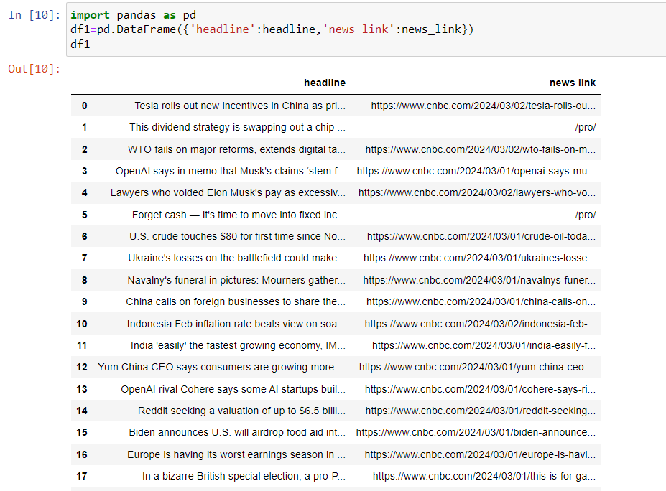

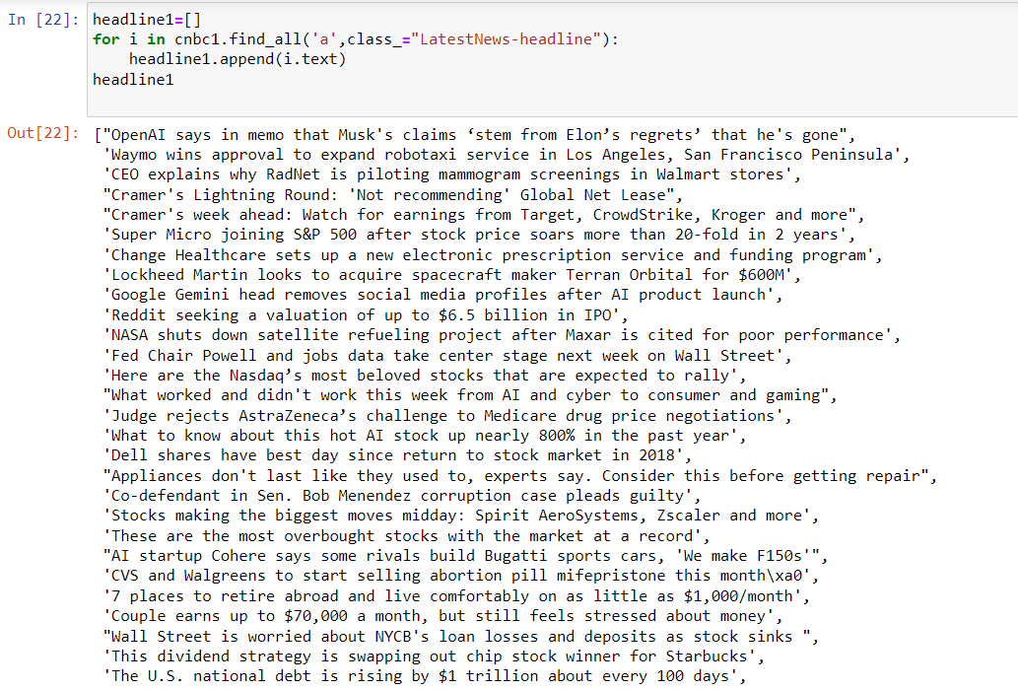

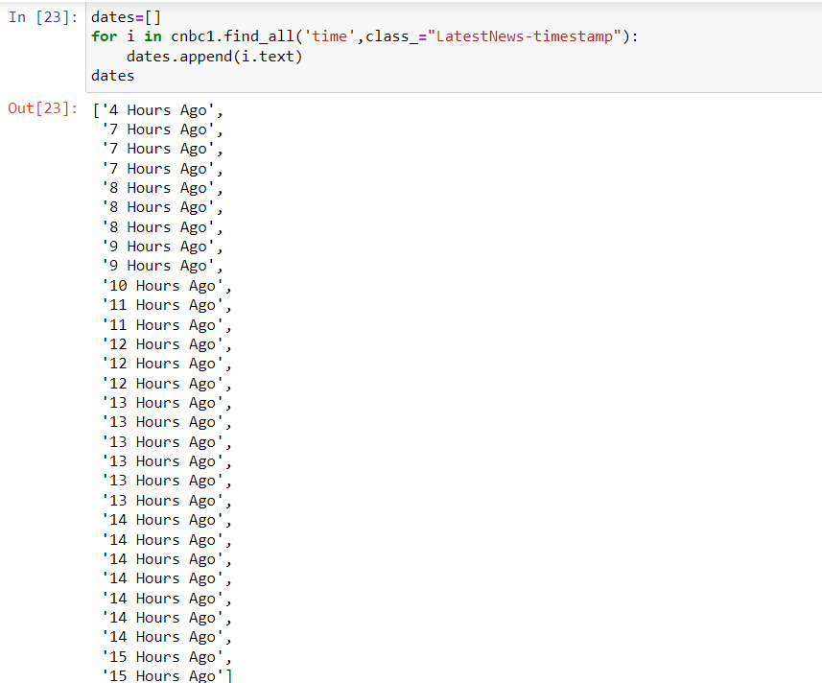

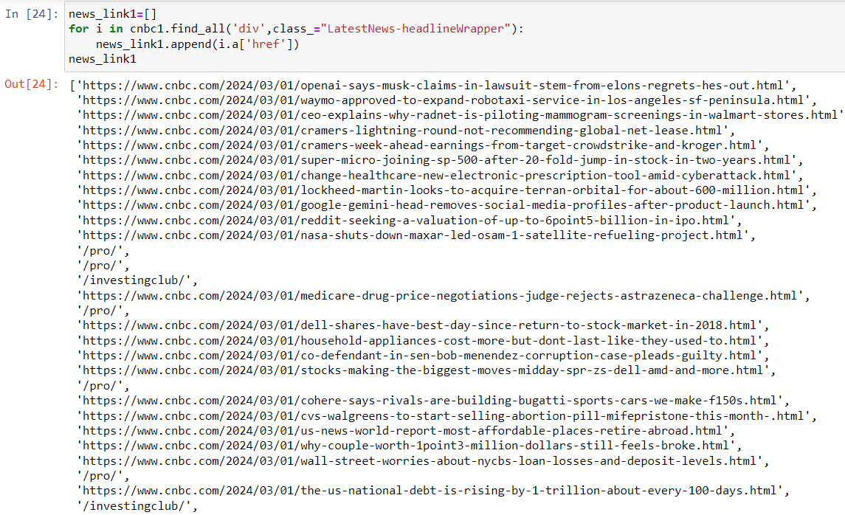

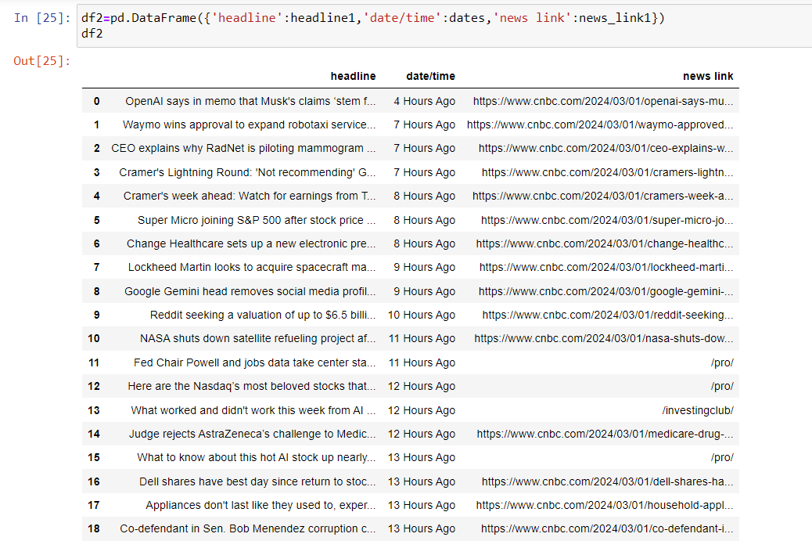

**Q2-Please visit**[**https://www.keaipublishing.com/en/journals/artificial-intelligence-in-agriculture/most-downloaded-articles/**](https://www.keaipublishing.com/en/journals/artificial-intelligence-in-agriculture/most-downloaded-articles/)**and scrap-**

**a) Paper title**

**b) date**

**c) Author**

**Ans)**

